# How ASPICE affects automotive development

### While the framework may seem daunting, ASPICE is actually largely generic. It does not dictate specific tools or techniques, but rather your approach to the internally selected development methods.

Many companies accept ASPICE Level 2, and Level 3 is the universal standard for excellence. Levels 4 and 5

are aspirational achievements usually attempted by large corporations.

Organizations can only learn by attempting to improve their standards. Without a standard for achievement, it would be

challenging to determine structured goals within the industry. ASPICE standards provide a benchmark for suppliers to ensure the stability of their processes and products, leading to an overall improvement in an industry where any mistake could cost you dearly.

Automotive SPICE certification requires both suppliers and clients to be rigorous about the products they put on

the road, and that alone will improve the automotive product quality standard.

But ASPICE steps beyond that by validating feedback and innovation. It recognizes

that improved standards can support continuous innovation in the automotive industry, and the resulting process improvement would positively impact not only developers but consumers en masse.

ASPICE standards also have the potential to reduce labor time and costs by integrating the testing process throughout production, limiting dangerous missteps and reducing product recalls. If every organization followed these standards, suppliers could identify problems and manage risks before a vehicle goes to market. ASPICE

also improves client-facing

processes, allowing suppliers to avoid miscommunication and provide greater transparency from the get-go. Wide-scale adoption could optimize the automotive industry at a pace that has not been witnessed since the advent of the assembly line.



# Reaching ASPICE compliance

For each ASPICE process on the V’s two prongs, there is a set of base practices defined. It is by following and implementing these practices, and providing evidence thereof, that your organization can achieve compliance with Automotive SPICE.

Your process capability level as per ASPICE will be determined by the following process attributes outlined by the ISO 15504 (SPICE) standard:

### Process performance

* **Performance management**

### Work product management

* **Process definition**

### Process deployment

* **Process measurement**

### Process control

* **Process innovation**

### Process optimization

To judge the degree of achievement, all these attributes will be evaluated using the following rating scale (as defined by ISO/IEC 33020):

There is **little or no evidence of achievement** of the

defined process attribute in the assessed process.

**Not**

achieved

**N**

There is **some evidence of an approach to, and some achievement of**, the defined process attribute in the assessed process. Some aspects of achievement of the process attribute may be unpredictable.

**Partially**

achieved

**P**

There is **evidence of a systematic approach to, and significant achievement of**, the defined process attribute in the assessed process. Some weaknesses related to this process attribute may exist in the assessed process.

**Largely**

achieved

**L**

There is **evidence of a complete and systematic approach to, and full achievement of**, the defined process attribute in the assessed process. No significant weaknesses related to this process attribute exist in the assessed process.

**Fully**

achieved

**F**

**Source:** [**ISO/IEC 33020**](https://cdn.standards.iteh.ai/samples/78526/e84f5951f904440092d79e0e881c1122/ISO-IEC-33020-2019.pdf) **– Information technology**

# Automotive SPICE in your organization

ASPICE is not a concrete set of systems and processes. It is a rough guideline to help suppliers develop a set of best practices that work for them. You can – and should – incorporate ASPICE standards at every level of production. The most important task is to understand the phases and certification levels. Then follow a few easy steps to assess whether your team is ASPICE-compliant:



### Use gap analysis to assess your current level of ASPICE compliance. Draw up a draft

of your existing processes to visualize how they fit into the ASPICE V-Model.

* + **Introduce the missing steps.** If you lack a clear differentiation between two phases,

create a plan to separate those two steps.

* + **Include stakeholders and team members.** Ensure awareness of the reasons for and guidelines of ASPICE standards. This will help you allocate the resources to begin operating under the new best practices.
  + **Incorporate a testing phase at each step of production.** This is the most important – and most challenging – phase of ASPICE compliance. Take the time to build a rigorous testing phase into each step of your new process!



# Motivation for ASPICE implementation

Organizations are mainly motivated (or pressured) by OEMs or Tier1 suppliers to implement ASPICE. This often means

a required CL (mainly CL3) in selected processes – and of course the continuous implementation of these processes.

However, this motivation that comes from an external source often leads to resistance against changes. This can result in higher costs and difficulties of maintaining process maturity for future projects.

## Process development vs business objectives

Business objectives and process development improvements aren’t always linked to each other. Even though people don’t always realize it, this relationship does in fact exist: the way teams work always impacts business goals. Streamlined processes can shorten development cycles, leading to reduced costs or improved quality. In

## How processes can make a measurable contribution to business goals

An effective approach is to gather management and

the process team in the same room to discuss potential improvements that will contribute to business objectives. These improvements must be measurable and trackable through KPIs.

## Processes



**Business objectives**

**Integration test process**

addition to these, improved processes might also lead to more satisfied employees. As a general framework to help process improvement, ASPICE can positively impact both.

**Decrease cost of non-quality in the field**

**KPI: No. of software**

**defects in the field**

**aims at**

**KPI: Coverage metric for integration tests**

**Improvement: increase coverage of integration tests**

**Source: Automotive SPICE Essentials (Abowd, Hoermann, Vanamali, Wall, 2020)**

# ASPICE implementation strategies

While ASPICE is not a process assessment model of the organization but of the individual project, in order to achieve CL3+ we need to think in terms of establishing processes on the organizational level. The key to achieving the desired capability level is to first define a strategy for achieving it, then carefully implementing that plan. The most commonly required – and therefore often the ultimate – goal of most organizations

is to achieve (pursue) Capability Level 3 for all processes as this provides

the best cost-benefit ratio.

According to ‘Automotive SPICE Essentials’ (Abowd, Hoermann,

Vanamali, Wall, 2020) there are three potential strategies:

**Strategy 1:** The sort of naive approach. Three levels, three phases. This takes the longest time and comes with the highest associated costs. The longer the project takes, the more opportunities there are to fail.

**Strategy 2:** Combining CL1 and CL2. This offers advantages as there actually is an overlap between CL1 and CL2. The three key processes of Project Management, Configuration Management, and QA support the implementation of CL2. If these processes are implemented

in a comprehensive way, CL2 is 90% implemented already. Most

organizations fail to take advantage of this.

**Strategy 3:** It may be initially more expensive, but is more efficient overall to implement all 3 levels in one go. The gain in efficiency can best be compared with Strategy 1, where you would need to enhance all process designs while transitioning to the next level. While with Strategy 3, all processes and all three levels are designed in one go.

Since CL3 deals with process standardization and requires significant organizational commitments and support, it is clear that all three strategies will require plenty of work – both at the project and the organizational level.

## Strategy 1 Strategy 2 Strategy 3

**CL 1 + CL 2**

**CL 3**

**CL 2**

**CL 1**

## CL 3

**CL 1 + CL 2 + CL3**



## Best practices for project-level ASPICE implementation

Many companies try to meet OEM requirements related to ASPICE by introducing it through a specific project instead of a large-scale initiative that would affect the entire development organization. A proven way to do this is to:

### Start with determining where the organization is at (perform a gap assessment as outlined above)

* **Plan and implement improvement activities**

### Assess the success of the implementation:

* + Not OK: re-execute the planning and implementation of improvement activities
  + OK: Assessment preparation, then OEM assessment.

## Best practices for organizational-level implementation

The disadvantage of the above, project-specific implementation is that it is difficult to apply these achievements to another project. Since projects may be slightly (or vastly) different, this approach leads to project-specific ASPICE implementations. The cost of project-specific

implementations can be much higher than the cost of an organizational- level implementation.

Taking that latter approach, of course, is more complex and comes with its own pitfalls. However, in the case of CL3, project-level implementations aren’t viable since CL3 talks about established processes on the organizational level.

To successfully implement changes on the organization level, you’ll need to consider the following success factors:

**Clear business motivation for the changes**



**Not**

**Check success (assessment)**

**Determine where you are**

**Plan & implement improvement activities**

**Experience with organizational changes**

**Incentives for a successful change**

**OK**

**Successful organizational change**

**Assessment preparation**

**OEM**

**Assessment**

**OK**

**Resources necessary for changes**

**Professional project management**

**Organizational change management**

**Commitment of all parties incl. management**

**Source: Automotive SPICE Essentials (Abowd, Hoermann, Vanamali, Wall, 2020)**

### A COMPREHENSIVE GUIDE TO AUTOMOTIVE SPICE

In general, it is important to break down such organizational-level changes to phases, similarly to the model outlined below in this illustration representing the key phases of an organizational change process:

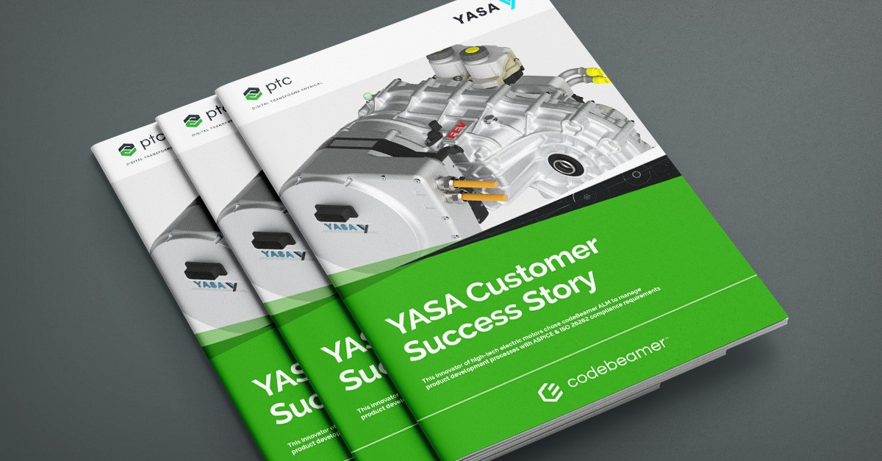

[**Interested in a real-life use case?**](https://intland.com/guides-brochures/success-stories/yasa/)

[**Download our case study to find out how this UK-based electromotor technology company tackles ASPICE & ISO 26262 requirements in an Agile environment!**](https://intland.com/guides-brochures/success-stories/yasa/)

**1**

**2**

**3**

**4**

**5**

### Initial phase

●

### Create awareness

●

### Assessing the

**status quo**

●

### Objectives

●

### Strategy

●

### Planning - commitments

●

### Staffing

●

### Organization

●

### Change management concept

**Delta phase**

●

### Changing and

**supplementing processes**

### Piloting phase

●

### Validate processes in practice

●

### Make processes fit for rollout

**Rollout phase**

●

### Rollout of processes

●

### Train, coach, and motivate staff

●

### Enhance processes based on feedback from practitioners

●

### Start systematic assessment preparation

**Institutionalization phase**

●

### Processes are becoming part of the

**organization’s culture**

●

### Assessment for checking success

**Source: Automotive SPICE Essentials (Abowd, Hoermann, Vanamali, Wall, 2020)**

# Introduction to Agile

### A hasty start can ruin everything

If the initial phase is neglected, you may start out with an immature concept and/or an unprepared organization. This could lead to an underestimation of effort, leaving out the right people, wrong objectives, inaccurate know-how, or a lack of motivation. In the initial phase, it is crucial to involve management.

Risk: Major implementation problems or even a complete failure of the implementation project.



### Not linking to business objectives

Without the appropriate linking to business objectives, one cannot communicate a clear business motivation. This may lead to lack of motivation among stakeholders and difficulties of managing change in the business. As the definition of success is missing, you may not be able to show proof of success.

Risk: The project has a low priority and doesn’t get enough management

attention or resources.







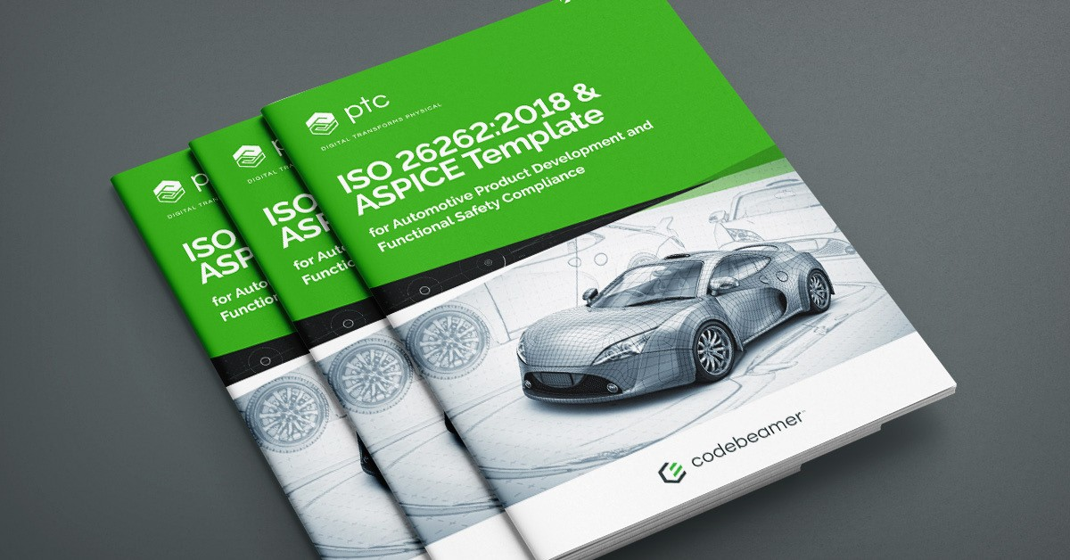

[**Preconfigured solution for your ASPICE needs**](https://content.intland.com/guides-brochures/intlands-automotive-iso-26262-aspice-template)

[**Ready to step into the new age of automotive safety? Reduce costly missteps –**](https://content.intland.com/guides-brochures/intlands-automotive-iso-26262-aspice-template)

[**try our ISO 26262 & ASPICE Template for a ready-made framework with baked-in work items and best practices for process optimization!**](https://content.intland.com/guides-brochures/intlands-automotive-iso-26262-aspice-template)

### Trying to win a race

Sustainable changes on the organizational level simply take time. Unrealistic time pressure (e.g. CL3 in one year) doesn’t make sense – but may still be set as a goal by top management.

Risk: Overloaded team, constantly corrected schedules, widespread disappointment regarding the implementation.

### Overengineered processes

Good processes are built based on practical solutions that work and are improved iteratively with feedback from the actual practitioners.

Risk: Processes designed in an ivory tower. Unrealistic or way too detailed processes that simply don’t work out in practice.

### Half-hearted investment

Objectives and resources of the project are often disproportionate: there is a budget, but it’s not sufficient. The result is that the company ends up burning a lot of money without real achievements. Risk: Unsuccessful implementation or a suboptimal cost/benefit ratio.

### Overall, not only is it possible to reach compliance with the necessary levels of Automotive SPICE, but it can also be greatly beneficial for your organization. By ensuring the maturity of processes, ASPICE helps developers of automotive products reduce the costs of risks, wasted resources, builds confidence in the quality of the company’s products – which in turn could positively impact market performance. While compliance with the requirements of ASPICE isn’t easy, careful planning and the use of adequate tools to support the transition go a long way in reducing associated costs.

**Sources: ‘Automotive SPICE Essentials’ (Abowd, Hoermann, Vanamali, Wall, 2020) /** [**Automotive SPICE® Process Reference Model Process**](http://www.automotivespice.com/fileadmin/software-download/Automotive_SPICE_PAM_30.pdf)[**Assessment / Model Version 3.0**](http://www.automotivespice.com/fileadmin/software-download/Automotive_SPICE_PAM_30.pdf) **/** [**What is ASPICE? by Andreas Zwinkau**](https://beza1e1.tuxen.de/aspice.html) **/** [**An ASPICE Overview by Michael Knop**](https://www.suse.com/c/an-aspice-overview/)





[**Simplify complex product & software engineering at scale**](https://intland.com/codebeamer/automotive-software-engineering/)

[**ALM for Automotive Embedded Systems Development**](https://intland.com/codebeamer/automotive-software-engineering/)

[**Find out why companies like Volkswagen, Daimler, and BMW are using Codebeamer!**](https://intland.com/codebeamer/automotive-software-engineering/)



121 Seaport Blvd, Boston, MA 02210 : ptc.com

**© 2023, PTC Inc. All rights reserved. Information described herein is furnished for informational use only, is subject to change without notice, and should not**

**be taken as a guarantee, commitment, condition or offer by PTC. PTC, the PTC logo, and all other PTC product names and logos are trademarks or registered**

**trademarks of PTC and/or its subsidiaries in the United States and other countries. All other product or company names are property of their respective owners.**

**004-a-comprehensive-guide-to-automotive-spice-02-07**